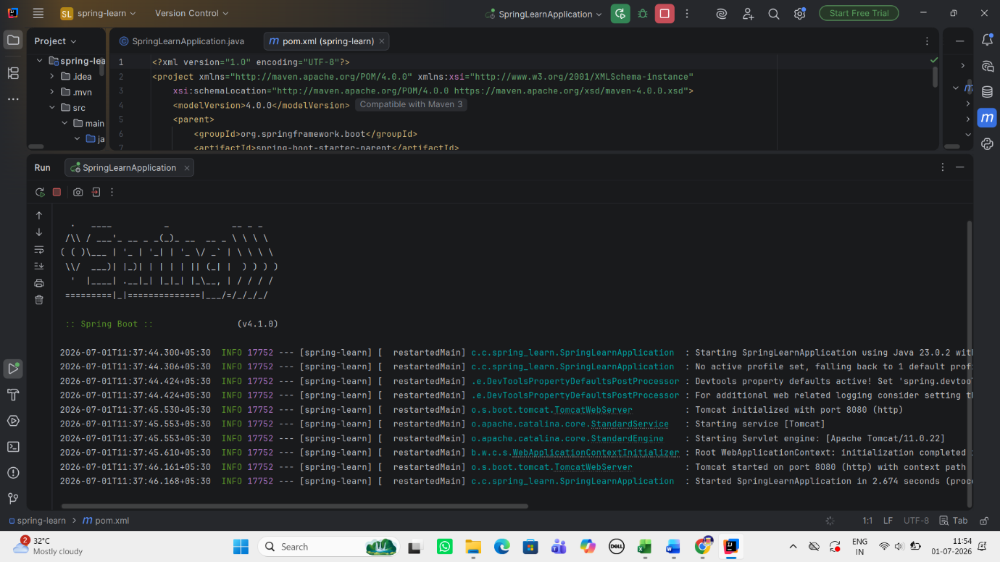
Dependencies :
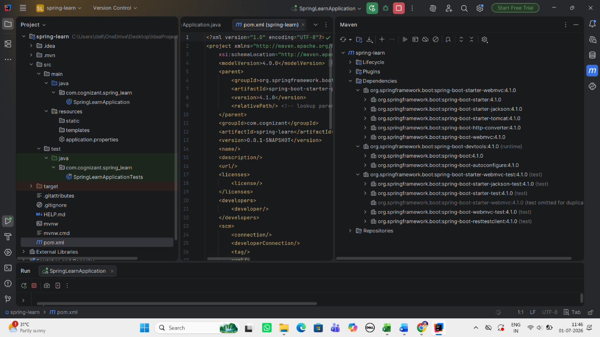

Purpose of @SpringBootApplication annotation
@SpringBootApplication acts as the starting point of a Spring Boot application. It reduces manual configuration, automatically sets up the required components, and prepares the application to run with minimal code.

